Bengaluru, Karnataka, India



AN INTERNSHIP REPORT ON

“Full Stack Web Development”

## BACHELOR OF ENGINEERING

In

#### COMPUTER SCIENCE AND ENGINEERING



##### Submitted by: TEJAS S(18BTRIS050)

JAIN UNIVERSITY-FET

**45th km, NH - 209 Kanakapura Road Jakkasandra, Post, Bengaluru,**

**Karnataka 562112**

**ABOUT THE COMPANY**

CST is a digital service provider that aims to provide software, designing and marketing solutions to individuals and businesses. At CST , we believe that service and quality is the key to success

We provide all kinds of technological and designing solutions from Billing Software to Web Designs or any custom demand that you may have. Experience the service like none other!

Some of our services include:

* Development - We develop responsive, functional and super-fast websites.
* We keep User Experience in mind while creating websites. A website should load quickly and shouldbe accessible even on a small view-port and slow internet connection.
* Mobile Application - We offer a wide range of professional Android, iOS& Hybrid app development services for our global clients, from a start up to a large enterprise.
* Design - We offer professional Graphic design, Brochure design & Logo design. We are expertsin crafting visual content to convey the right message to the customers.
* Consultancy - We are here to provide you with expert advice on your design and development requirement.
* Videos - We create a polished professional video that impresses your audience.

# Table of Contents

#### Contents Page No.

**Table of Contents I**

Overview of the project 1

About 2

Tools used 3

Implementation 4-34

Snapshots 35-38

Biblography 39

### OVERVIEW OF THE PROJECT

**Project Name**: VTU SGPA/CGPA Calculator

**Team Members:**

TEJAS S (18BTRIS050)

This project is based on Web Development and its Applications. The main objective of this project is to learn the implementation of HTML, CSS and JavaScript at frontend and PHP, MySQL database at backend, The webpage of this project is created using HTML and styling of the webpage is done using CSS.

It is a web application that simplifies the task of storing a users results . The system is flexible to be used and reduces the need of frequently searching and accessing an individuals marks. The system is developed to provide an easy means for storing semester wise results. Individuals have to login and enter their marks in a form.They can then access the result and print it in a PDF format.

1. **USER MODULE**

This module is mainly dedicated to the candidates who are looking to store their result. They can log in into the system, via the credentials provided to them & once they are in, they have to enter their data by filling an online form . They can download the result from the same module, in PDF file format.

1. **ADMIN MODULE**

This module is maintained by the admin and only he/she can manage and have access to every account. Admin can add or delete the users as well. They can modify the functionalities of the system, too. Admin can also add users on the fly to the application to make the application full of new functionalities.

**SGPA/CGPA Calculator**

CGPA refers to the cumulative grade point average which literally translates to the sum total of all your credit points. This system helps in assessing the overall academic performance of a student. Although the evaluation criteria may vary from one country to another, the CGPA system is among the most common evaluation way in most professional/technical courses.

SGPA, which stands for Semester Grade Point Average is an evaluation method that highlights the semester wise performance of the student. It can be calculated by simply adding all the credit points awarded for the subjects and then dividing it by the total credits allotted to that semester.

Now let’s look at how to calculate SGPA and CGPA respectively by taking an example

In a total of 3 subjects, you scored the following grade points:

Subject1:8

Subject2:6

Subject 3: 7

The total credit for each subject is 10.

1. Now, first we will multiply, the grade point with the total credit point for each subject:

Subject 1: 8*10 = 80

Subject 2: 6*10 = 60

Subject 3: 7*10 = 70

2. To calculate SGPA here, you need to add all these grade points and then divide it by the total credits, i.e.

Total grade points: 210

Total credits: 30

To get SGPA, divide grade points by total credits, =210/30 =7 SGPA

To find CGPA from SGPA, you need to follow this formula:

CGPA= (SGPAs of All semesters in an academic year)/ Number of semesters

Thus, by adding up all the SGPAs you have got in an academic year by the total number of semesters, you will find CGPA from SGPA.

For example,

Suppose that you scored 7 SGPA and 9 SGPA in your two semesters.

1. First you need to add both these SGPAs.

2. Then, divide the total SGPA with the number of semesters, i.e.

3. Your CGPA would be: CGPA = SGPA of all semesters in a year/Number of semesters = (7+9)/2 = 8 CGPA

### TOOLS USED

**Software Requirements**

* + Visual Studio Code 2019.
  + Google Chrome or Microsoft Edge of latest version.
  + Front End: HTML, CSS, JS
  + Backend : Php, MySQL, Xampp
  + Linux 7.1 or Windows XP/7/8/10 OS or Mac OS

**Hardware Requirements**

* + Pentium 200-MHz computer with a minimum of 64 MB of RAM (128 MB of RAM recommended).
  + Monitor with a refresh rate of at least 40Hz for a smooth GUI experience (optional).

# IMPLEMENTATION

# This Code section contains the important code snippets as the whole file is quite large, the whole code can be found in the following GitHub repository: https://github.com/tejasreddy47/Dec2021FullStackWebDevelopment

<!DOCTYPE HTML>

<html lang="en">

<head>

    <title>VTU Calculator</title>

    <meta name="viewport" content="width=device-width, initial-scale=1">

    <meta charset="utf-8">

    <meta name="keywords" content="sgpa Calculator, Calculator, cgpa Calculator, VTU, cbcs,non cbcs" />

    <script>

        addEventListener("load", function () {

            setTimeout(hideURLbar, 0);

        }, false);

        function hideURLbar() {

            window.scrollTo(0, 1);

        }

    </script>

    <!-- Bootstrap Core CSS -->

    <link href="static/css/bootstrap.css" rel='stylesheet' type='text/css' />

    <!-- Custom CSS -->

    <link href="static/css/style.css" rel='stylesheet' type='text/css' />

     <!-- font-awesome icons -->

    <link  href="static/css/fontawesome-all.min.css" rel="stylesheet">

    <!-- pop up box -->

    <link href="static/css/popup-box.css" rel="stylesheet" type="text/css" media="all" />

    <link rel="stylesheet" href="static/css/owl.carousel.css" type="text/css" media="all">

    <link rel="stylesheet" href="static/css/owl.theme.css" type="text/css" media="all">

    <!-- Carousel (for News section) -->

    <!-- //Custom Theme files -->

    <!-- online fonts -->

    <!-- <link href="//fonts.googleapis.com/css?family=Poppins:100,100i,200,200i,300,300i,400,400i,500,500i,600,600i,700,700i,800,800i,900,900i"

        rel="stylesheet">

    <link href="//fonts.googleapis.com/css?family=Gentium+Book+Basic:400,400i,700i" rel="stylesheet"> -->

    <!--//online fonts -->

</head>

<body>

    <!-- header -->

    <header>

        <div class="header-bottom">

            <div class="container">

                <nav class="navbar navbar-expand-lg navbar-light p-0">

                    <h1><a class="navbar-brand" href="index.html">

                           VTU Calculator

                        </a></h1>

                    <button class="navbar-toggler ml-lg-auto ml-sm-5" type="button" data-toggle="collapse" data-target="#navbarSupportedContent"

                        aria-controls="navbarSupportedContent" aria-expanded="false" aria-label="Toggle navigation">

                        <span class="navbar-toggler-icon"></span>

                    </button>

                    <div class="collapse navbar-collapse" id="navbarSupportedContent">

                        <ul class="navbar-nav text-center ml-auto">

                            <li class="nav-item  mr-lg-3 mt-lg-0 mt-4">

                              <a class="hover-fill" aria-pressed="false" href="index.html" data-txthover="PERCENTAGE CALCULATOR">PERCENTAGE CALCULATOR</a>

                            </li>

                            <li class="nav-item  mr-lg-3 mt-lg-0 mt-4">

                                <a class="hover-fill" aria-pressed="false" href="sgpa.html" data-txthover="SGPA CALCULATOR">SGPA CALCULATOR</a>

                            </li>

                            <li class="nav-item">

                                <a class="hover-fill" aria-pressed="false" href="cgpa.html" data-txthover="CGPA CALCULATOR">CGPA CALCULATOR</a>

                            </li>

                        </ul>

                    </div>

                </nav>

            </div>

        </div>

    </header>

    <!-- //header -->

    <!-- banner -->

    <div class="screenview_bg bg-theme px-3">

        <div class="container">

          <section class="wthree-row w3-gallery py-5">

                <div class="container py-xl-5">

                    <div class="w3l_header mb-sm-5 pb-3">

                <h3 class="text-center">VTU CGPA Calculator</h3>

                    </div>

            </div>

            <div class="row">

              <div class="col">

                <div class="container">

                <div class="login mb-sm-5 px-4 mx-auto mw-100">

                <form id="choose" action="#" method="post">

                    <fieldset>

                      <legend class="pl-5">Choose accordingly</legend>

                      <div class="form-row">

                          <div class="col-md-4"></div>

                        <div class="form-group col-md-2 mb-4">

                            <label class="col-form-label">Scheme</label>

                        </div>

                        <div class="col-md-2 mb-4">

                          <select class="form-control" id="scheme">

                            <option value="2018_scheme">2018</option>

                            <option value="2017_scheme">2017</option>

                          </select>

                        </div>

                      </div>

                    </fieldset>

                    <br>

                    <div class='text-center' style="margin-top: 10px">

                        <button type="submit" class="get-started-btn">Submit</button>

                    </div>

                </form>

          </section>

        </div>

    </div>

    <!-- //banner -->

    <!-- js -->

    <script src="static/js/jquery-2.2.3.min.js"></script>

    <!--pop-up-box -->

    <script src="static/js/jquery.magnific-popup.js"></script>

  <script type="text/javascript">

    document.getElementById('choose').onsubmit = function() {

        window.location.replace("calc/"+document.getElementById('scheme').value+'.html');

        return false;

    };

  </script>

    <script>

        $(document).ready(function () {

            $('.popup-with-zoom-anim').magnificPopup({

                type: 'inline',

                fixedContentPos: false,

                fixedBgPos: true,

                overflowY: 'auto',

                closeBtnInside: true,

                preloader: false,

                midClick: true,

                removalDelay: 300,

                mainClass: 'my-mfp-zoom-in'

            });

        });

    </script>

    <!-- //pop-up-box -->

    <!-- start-smooth-scrolling -->

    <script src="static/js/move-top.js" ></script>

    <script src="static/js/easing.js"></script>

    <script>

        jQuery(document).ready(function ($) {

            $(".scroll").click(function (event) {

                event.preventDefault();

                $('html,body').animate({

                    scrollTop: $(this.hash).offset().top

                }, 1000);

            });

        });

    </script>

    <!-- //end-smooth-scrolling -->

     <!-- carousel -->

    <script src="static/js/owl.carousel.js"></script>

    <script>

        $(document).ready(function() {

            $('.owl-carousel').owlCarousel({

                loop: true,

                margin: 10,

                responsiveClass: true,

                responsive: {

                    0: {

                        items: 1,

                        nav: true

                    },

                    600: {

                        items: 1,

                        nav: false

                    },

                    900: {

                        items: 1,

                        nav: false

                    },

                    1000: {

                        items: 3,

                        nav: true,

                        loop: false,

                        margin: 20

                    }

                }

            })

        })

    </script>

    <!-- //carousel -->

    <!-- smooth-scrolling-of-move-up -->

    <script>

        $(document).ready(function () {

            /*

             var defaults = {

                 containerID: 'toTop', // fading element id

                 containerHoverID: 'toTopHover', // fading element hover id

                 scrollSpeed: 1200,

                 easingType: 'linear'

             };

             */

            $().UItoTop({

                easingType: 'easeOutQuart'

            });

        });

    </script>

    <script src="static/js/SmoothScroll.min.js"></script>

    <script src="static/js/bootstrap.js"></script>

</body>

</html>

<!DOCTYPE HTML>

<html lang="en">

<head>

    <title>VTU Calculator | </title>

    <meta name="viewport" content="width=device-width, initial-scale=1">

    <meta charset="utf-8">

    <meta name="keywords" content="sgpa Calculator, Calculator, cgpa Calculator, VTU, cbcs,non cbcs" />

    <script>

        addEventListener("load", function () {

            setTimeout(hideURLbar, 0);

        }, false);

        function hideURLbar() {

            window.scrollTo(0, 1);

        }

    </script>

    <!-- Bootstrap Core CSS -->

    <link href="static/css/bootstrap.css" rel='stylesheet' type='text/css' />

    <!-- Custom CSS -->

    <link href="static/css/style.css" rel='stylesheet' type='text/css' />

     <!-- font-awesome icons -->

    <link  href="static/css/fontawesome-all.min.css" rel="stylesheet">

    <!-- pop up box -->

    <link href="static/css/popup-box.css" rel="stylesheet" type="text/css" media="all" />

    <link rel="stylesheet" href="static/css/owl.carousel.css" type="text/css" media="all">

    <link rel="stylesheet" href="static/css/owl.theme.css" type="text/css" media="all">

    <!-- Carousel (for News section) -->

    <!-- //Custom Theme files -->

    <!-- online fonts -->

    <!-- <link href="//fonts.googleapis.com/css?family=Poppins:100,100i,200,200i,300,300i,400,400i,500,500i,600,600i,700,700i,800,800i,900,900i"

        rel="stylesheet">

    <link href="//fonts.googleapis.com/css?family=Gentium+Book+Basic:400,400i,700i" rel="stylesheet"> -->

    <!--//online fonts -->

</head>

<body>

    <!-- header -->

    <header>

        <div class="header-bottom">

            <div class="container">

                <nav class="navbar navbar-expand-lg navbar-light p-0">

                    <h1><a class="navbar-brand" href="index.html">

                           VTU Calc

                        </a></h1>

                    <button class="navbar-toggler ml-lg-auto ml-sm-5" type="button" data-toggle="collapse" data-target="#navbarSupportedContent"

                        aria-controls="navbarSupportedContent" aria-expanded="false" aria-label="Toggle navigation">

                        <span class="navbar-toggler-icon"></span>

                    </button>

                    <div class="collapse navbar-collapse" id="navbarSupportedContent">

                        <ul class="navbar-nav text-center ml-auto">

                            <li class="nav-item  mr-lg-3 mt-lg-0 mt-4">

                              <a class="hover-fill" aria-pressed="false" href="index.html" data-txthover="PERCENTAGE CALCULATOR">PERCENTAGE CALCULATOR</a>

                            </li>

                            <li class="nav-item  mr-lg-3 mt-lg-0 mt-4">

                                <a class="hover-fill" aria-pressed="false" href="sgpa.html" data-txthover="SGPA CALCULATOR">SGPA CALCULATOR</a>

                            </li>

                            <li class="nav-item">

                                <a class="hover-fill" aria-pressed="false" href="cgpa.html" data-txthover="CGPA CALCULATOR">CGPA CALCULATOR</a>

                            </li>

                        </ul>

                    </div>

                </nav>

            </div>

        </div>

    </header>

    <!-- //header -->

    <!-- banner -->

    <div class="screenview_bg bg-theme px-3">

        <div class="container">

          <section class="wthree-row w3-gallery py-5">

                <div class="container py-xl-5">

                    <div class="w3l_header mb-sm-5 pb-3">

                <h3 class="text-center">VTU SGPA Calculator</h3>

                    </div>

            </div>

            <div class="row">

              <div class="col">

                <div class="container">

                <div class="login mb-sm-5 px-4 mx-auto mw-100">

                <form id="choose" action="#" method="post">

                    <fieldset>

                      <legend>Choose accordingly</legend>

                      <div class="form-row">

                        <div class="form-group col-md-6 mb-4">

                            <label class="col-form-label">Sem</label>

                        </div>

                        <div class="col-md-6 mb-4">

                          <select class="form-control" id="sem">

                            <option value="1st_sem">1st sem</option>

                            <option value="2nd_sem">2nd sem</option>

                            <option value="3rd_sem">3rd sem</option>

                            <option value="4th_sem">4th sem</option>

                            <option value="5th_sem">5th sem</option>

                            <option value="6th_sem">6th sem</option>

                            <option value="7th_sem">7th sem</option>

                            <option value="8th_sem">8th sem</option>

                          </select>

                        </div>

                      </div>

                      <div class="form-row">

                        <div class="form-group col-md-6 mb-4">

                            <label class="col-form-label">Branch</label>

                        </div>

                        <div class="col-md-6 mb-4">

                          <select class="form-control" id="branch">

                            <option value="1" >B.E-AERONAUTICAL ENGINEERING</option>

                            <option value="2" >B.E-AUTOMOBILE ENGINEERING</option>

                            <option value="3" >B.E-BIO-MEDICAL ENGINEERING</option>

                            <option value="4" >B.E-BIOTECHNOLOGY</option>

                            <option value="5" >B.E-CERAMICS & CEMENT TECHNOLOGY</option>

                            <option value="6" >B.E-CHEMICAL ENGINEERING</option>

                            <option value="7" >B.E-CIVIL ENGINEERING</option>

                            <option value="8" >B.E-COMPUTER SCIENCE & ENGINEERING</option>

                            <option value="9" >B.E-CONSTRUCTION TECHNOLOGY AND MANAGEMENT</option>

                            <option value="10">B.E-PRECISION MANUFACTURING</option>

                            <option value="11">B.E-ELECTRICAL & ELECTRONICS ENGINEERING</option>

                            <option value="12">B.E-ELECTRONICS & COMMUNICATION ENGINEERING</option>

                            <option value="13">B.E-ENVIRONMENTAL ENGINEERING</option>

                            <option value="14">B.E-INDUSTRIAL & PRODUCTION ENGINEERING</option>

                            <option value="15">B.E-INDUSTRIAL ENGINEERING & MANAGEMENT</option>

                            <option value="16">B.E-INFORMATION SCIENCE & ENGINEERING</option>

                            <option value="17">B.E-INSTRUMENTATION TECHNOLOGY</option>

                            <option value="18">B.E-MANUFACTURING SCIENCE & ENGINEERING</option>

                            <option value="19">B.E-MECHANICAL ENGINEERING</option>

                            <option value="20">B.E-MECHATRONICS ENGINEERING</option>

                            <option value="21">B.E-MEDICAL ELECTRONICS</option>

                            <option value="22">B.E-MINING ENGINEERING</option>

                            <option value="23">B.E-POLYMER SCIENCE & TECHNOLOGY</option>

                            <option value="24">B.E-PRINTING TECHNOLOGY</option>

                            <option value="25">B.E-SILK TECHNOLOGY</option>

                            <option value="26">B.E-TELECOMMUNICATION ENGINEERING</option>

                            <option value="27">B.E-TEXTILE TECHNOLOGY</option>

                            <option value="28">B.E-TRANSPORTATION ENGINEERING</option>

                            <option value="29">B.E-TOOL ENGINEERING</option>

                          </select>

                        </div>

                      </div>

                      <div class="form-row">

                        <div class="form-group col-md-6 mb-4">

                            <label class="col-form-label">Scheme</label>

                        </div>

                        <div class="col-md-6 mb-4">

                          <select class="form-control" id="scheme">

                            <option value="2018_scheme">2018</option>

                            <option value="2017_scheme">2017</option>

                            <!-- <option value="2015_scheme">2015</option> -->

                          </select>

                        </div>

                      </div>

                    </fieldset>

                    <br>

                    <div class='text-center' style="margin-top: 10px">

                        <button type="submit" class="get-started-btn">Submit</button>

                    </div>

                </form>

          </section>

        </div>

    </div>

    <!-- //banner -->

    <!-- js -->

    <script src="static/js/jquery-2.2.3.min.js"></script>

    <!--pop-up-box -->

    <script src="static/js/jquery.magnific-popup.js"></script>

  <script type="text/javascript">

    document.getElementById('choose').onsubmit = function() {

        if (document.getElementById('sem').value=="7th_sem" && document.getElementById('scheme').value=="2018_scheme" && document.getElementById('branch').value == 8) {

            window.location.replace("calc/"+document.getElementById('scheme').value+'-'+document.getElementById('sem').value+'s.html');

            return false;

        }

        window.location.replace("calc/"+document.getElementById('scheme').value+'-'+document.getElementById('sem').value+'.html?br='+document.getElementById('branch').value);

        return false;

    };

  </script>

    <script>

        $(document).ready(function () {

            $('.popup-with-zoom-anim').magnificPopup({

                type: 'inline',

                fixedContentPos: false,

                fixedBgPos: true,

                overflowY: 'auto',

                closeBtnInside: true,

                preloader: false,

                midClick: true,

                removalDelay: 300,

                mainClass: 'my-mfp-zoom-in'

            });

        });

    </script>

    <!-- //pop-up-box -->

    <!-- start-smooth-scrolling -->

    <script src="static/js/move-top.js" ></script>

    <script src="static/js/easing.js"></script>

    <script>

        jQuery(document).ready(function ($) {

            $(".scroll").click(function (event) {

                event.preventDefault();

                $('html,body').animate({

                    scrollTop: $(this.hash).offset().top

                }, 1000);

            });

        });

    </script>

    <!-- //end-smooth-scrolling -->

     <!-- carousel -->

    <script src="static/js/owl.carousel.js"></script>

    <script>

        $(document).ready(function() {

            $('.owl-carousel').owlCarousel({

                loop: true,

                margin: 10,

                responsiveClass: true,

                responsive: {

                    0: {

                        items: 1,

                        nav: true

                    },

                    600: {

                        items: 1,

                        nav: false

                    },

                    900: {

                        items: 1,

                        nav: false

                    },

                    1000: {

                        items: 3,

                        nav: true,

                        loop: false,

                        margin: 20

                    }

                }

            })

        })

    </script>

    <!-- //carousel -->

    <!-- smooth-scrolling-of-move-up -->

    <script>

        $(document).ready(function () {

            /*

             var defaults = {

                 containerID: 'toTop', // fading element id

                 containerHoverID: 'toTopHover', // fading element hover id

                 scrollSpeed: 1200,

                 easingType: 'linear'

             };

             */

            $().UItoTop({

                easingType: 'easeOutQuart'

            });

        });

    </script>

    <script src="static/js/SmoothScroll.min.js"></script>

    <script src="static/js/bootstrap.js"></script>

</body>

</html>

<!DOCTYPE HTML>

<html lang="en">

<head>

    <title>CALCULATOR</title>

    <meta name="viewport" content="width=device-width, initial-scale=1">

    <meta charset="utf-8">

    <meta name="keywords" content="sgpa Calculator, Calculator, cgpa Calculator, VTU, cbcs,non cbcs" />

    <script>

        addEventListener("load", function () {

            setTimeout(hideURLbar, 0);

        }, false);

        function hideURLbar() {

            window.scrollTo(0, 1);

        }

    </script>

    <!-- Bootstrap Core CSS -->

    <link href="static/css/bootstrap.css" rel='stylesheet' type='text/css' />

    <!-- Custom CSS -->

    <link href="static/css/style.css" rel='stylesheet' type='text/css' />

     <!-- font-awesome icons -->

    <link  href="static/css/fontawesome-all.min.css" rel="stylesheet">

    <!-- pop up box -->

    <link href="static/css/popup-box.css" rel="stylesheet" type="text/css" media="all" />

    <link rel="stylesheet" href="static/css/owl.carousel.css" type="text/css" media="all">

    <link rel="stylesheet" href="static/css/owl.theme.css" type="text/css" media="all">

    <!-- Carousel (for News section) -->

    <!-- //Custom Theme files -->

    <!-- online fonts -->

    <!-- <link href="//fonts.googleapis.com/css?family=Poppins:100,100i,200,200i,300,300i,400,400i,500,500i,600,600i,700,700i,800,800i,900,900i"

        rel="stylesheet">

    <link href="//fonts.googleapis.com/css?family=Gentium+Book+Basic:400,400i,700i" rel="stylesheet"> -->

    <!--//online fonts -->

</head>

<body>

    <!-- header -->

    <header>

        <div class="header-bottom">

            <div class="container">

                <nav class="navbar navbar-expand-lg navbar-light p-0">

                    <h1><a class="navbar-brand" href="index.html">

                           CGPA AND SGPA CALCULATOR FOR VTU

                        </a></h1>

                    <button class="navbar-toggler ml-lg-auto ml-sm-5" type="button" data-toggle="collapse" data-target="#navbarSupportedContent"

                        aria-controls="navbarSupportedContent" aria-expanded="false" aria-label="Toggle navigation">

                        <span class="navbar-toggler-icon"></span>

                    </button>

                    <div class="collapse navbar-collapse" id="navbarSupportedContent">

                        <ul class="navbar-nav text-center ml-auto">

                          <li class="nav-item  mr-lg-3 mt-lg-0 mt-4">

                            <a class="hover-fill" aria-pressed="false" href="index.html" data-txthover="PERCENTAGE CALCULATOR">PERCENTAGE CALCULATOR</a>

                          </li>

                          <li class="nav-item  mr-lg-3 mt-lg-0 mt-4">

                              <a class="hover-fill" aria-pressed="false" href="sgpa.html" data-txthover="SGPA CALCULATOR">SGPA CALCULATOR</a>

                          </li>

                          <li class="nav-item">

                              <a class="hover-fill" aria-pressed="false" href="cgpa.html" data-txthover="CGPA CALCULATOR">CGPA CALCULATOR</a>

                          </li>

                        </ul>

                </nav>

            </div>

        </div>

    </header>

    <!-- //header -->

    <!-- banner -->

    <div class="screenview_bg bg-theme px-3">

        <div class="container">

          <section class="wthree-row w3-gallery py-5">

                <div class="container py-xl-5">

                <h3 class="text-center">VTU Percentage Calculator</h3>

                    </div>

            </div>

                <!-- //gallery container -->

                <div class="container">

                <div class="login mb-sm-5 px-4 mx-auto mw-100">

                <form id="cgpac" action="#" method="post">

                    <fieldset>

                      <div class="row justify-content-md-center">

                        <div class="col-5">

                          <div class="form-row">

                            <div class="form-group col-md-6 mb-4">

                                <label class="col-form-label">CGPA/SGPA</label>

                            </div>

                            <div class="col-md-6 mb-4">

                              <input type="text" class="form-control" id="gpa" name="gpa" placeholder="CGPA/SGPA" required>

                            </div>

                          </div>

                        </div>

                      </div>

                    </fieldset>

                  <br>

                    <div class='text-center' style="margin-top: 10px">

                        <button type="submit" class="get-started-btn">Calculate Percentage</button>

                    </div>

                </form>

                </div>

              </div>

              <div class="row">

              <div class="col">

                <fieldset disabled>

                    <div class="container" style="margin:0 auto; width: 50%;">

                        <legend>Result</legend>

                        <div class="form-row">

                            <div class="form-group col-md-6 mb-4">

                                <label class="col-form-label">Percentage</label>

                            </div>

                            <div class="col-md-6 mb-4">

                                <input type="text" id="percentage" class="form-control" placeholder="Percentage">

                            </div>

                        </div>

                    </div>

                </fieldset>

              </div>

            </div>

        </section>

    </div>

    </div>

    <!-- //banner -->

    <!-- js -->

    <script src="static/js/jquery-2.2.3.min.js"></script>

    <!--pop-up-box -->

    <script src="static/js/jquery.magnific-popup.js"></script>

  <script type="text/javascript">

    document.getElementById('cgpac').onsubmit = function() {

        var percentage;

        var g = document.getElementById('gpa').value;

        percentage = (g-0.75)*10;

        document.getElementById('percentage').value = percentage.toFixed(2);

        return false;

    };

  </script>

    <script>

        $(document).ready(function () {

            $('.popup-with-zoom-anim').magnificPopup({

                type: 'inline',

                fixedContentPos: false,

                fixedBgPos: true,

                overflowY: 'auto',

                closeBtnInside: true,

                preloader: false,

                midClick: true,

                removalDelay: 300,

                mainClass: 'my-mfp-zoom-in'

            });

        });

    </script>

    <!-- //pop-up-box -->

    <!-- start-smooth-scrolling -->

    <script src="static/js/move-top.js" ></script>

    <script src="static/js/easing.js"></script>

    <script>

        jQuery(document).ready(function ($) {

            $(".scroll").click(function (event) {

                event.preventDefault();

                $('html,body').animate({

                    scrollTop: $(this.hash).offset().top

                }, 1000);

            });

        });

    </script>

    <!-- //end-smooth-scrolling -->

     <!-- carousel -->

    <script src="static/js/owl.carousel.js"></script>

    <script>

        $(document).ready(function() {

            $('.owl-carousel').owlCarousel({

                loop: true,

                margin: 10,

                responsiveClass: true,

                responsive: {

                    0: {

                        items: 1,

                        nav: true

                    },

                    600: {

                        items: 1,

                        nav: false

                    },

                    900: {

                        items: 1,

                        nav: false

                    },

                    1000: {

                        items: 3,

                        nav: true,

                        loop: false,

                        margin: 20

                    }

                }

            })

        })

    </script>

    <!-- //carousel -->

    <!-- smooth-scrolling-of-move-up -->

    <script>

        $(document).ready(function () {

            /*

             var defaults = {

                 containerID: 'toTop', // fading element id

                 containerHoverID: 'toTopHover', // fading element hover id

                 scrollSpeed: 1200,

                 easingType: 'linear'

             };

             */

            $().UItoTop({

                easingType: 'easeOutQuart'

            });

        });

    </script>

    <script src="static/js/SmoothScroll.min.js"></script>

    <script src="static/js/bootstrap.js"></script>

</body>

</html>

# CSS STYLE

/*

Author: W3layout

Author URL: http://w3layouts.com

License: Creative Commons Attribution 3.0 Unported

License URL: http://creativecommons.org/licenses/by/3.0/

*/

# BOOTSTRAP

# /*!

# * Bootstrap v4.0.0 (https://getbootstrap.com)

# * Copyright 2011-2018 The Bootstrap Authors

# * Copyright 2011-2018 Twitter, Inc.

# * Licensed under MIT (https://github.com/twbs/bootstrap/blob/master/LICENSE)

# */

### 

### SNAPSHOTS

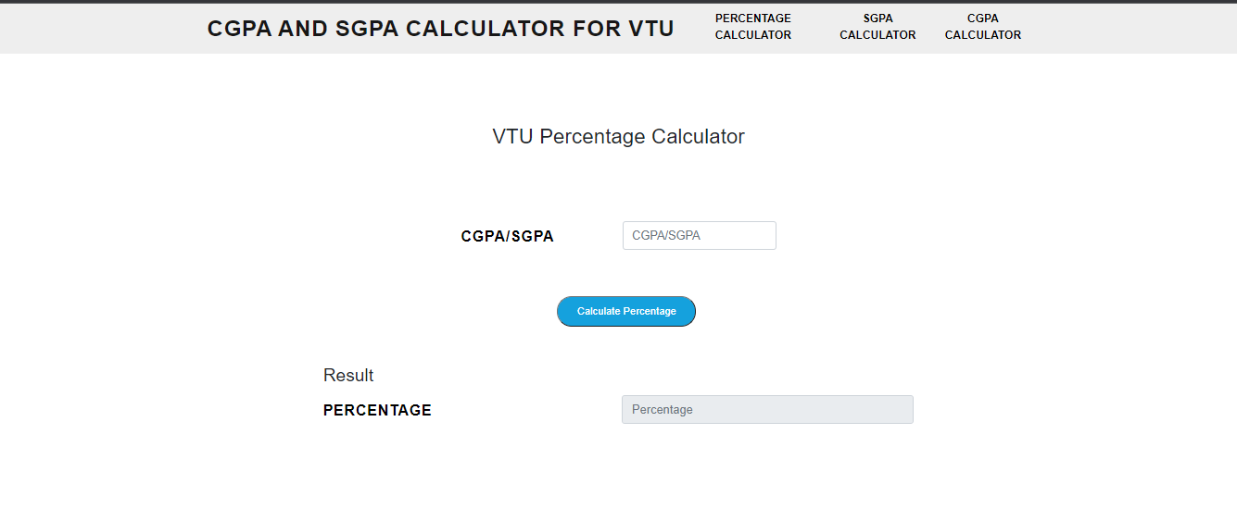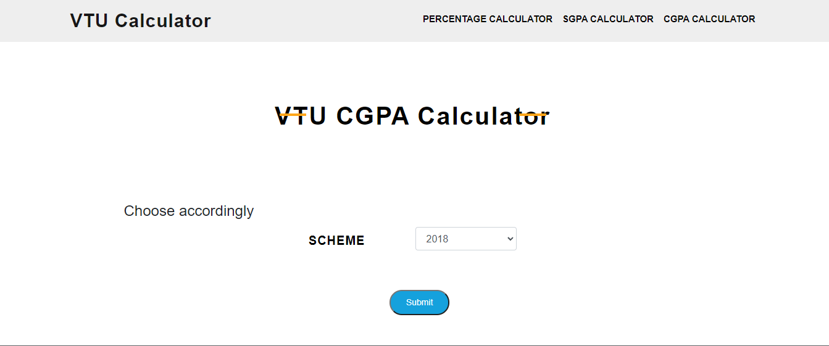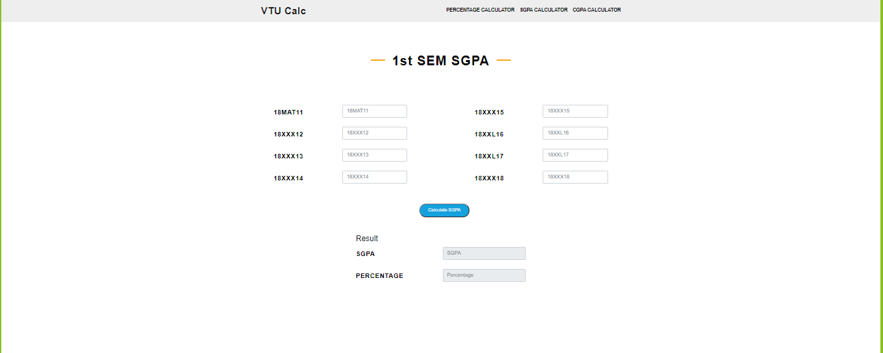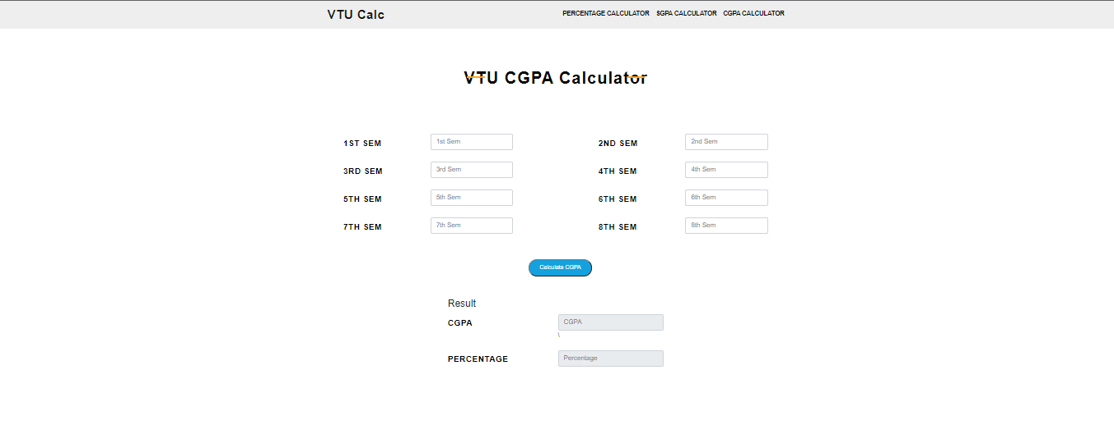

### BIBLIOGRAPHY

* https://[www.w3schools.com](http://www.w3schools.com/)
* https://www.geeksforgeeks org
* https://freefrontend.com
* <https://css-tricks.com/>
* https://www.takeiteasyengineers.com
* https://dev.to/mychi_darko/php-tips-and-tricks-4kpn